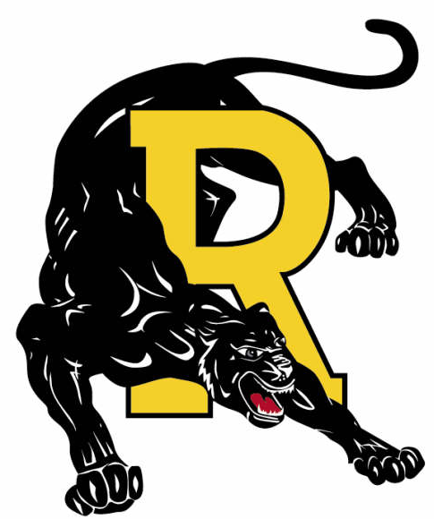
Royall Elementary Schools
Class Supply Lists ~ 2024-2025

GRADE | 4K | K | 1 | 2 | 3 | 4 | 5 | 6
Box 24 - Crayola Crayons |  | 3 | 2 | 2 | 1 | 1 | 1
Pencil Box (standard size – hard cover) |  | 1 | 1 | 1 | 1 |  | 1
Pencil Case (soft – hook in 3 ring binder) |  |  |  |  |  | 1 | 1 | 1
Pencils - #2 Wooden (Ticonderoga preferred) |  | 12 | 20 | 24 | 24 | 24 | 24 | 12
Crayola Colored Pencils – Box of 12 |  |  | 2 | 2 | 2 | 2 | 1 | 1
Ballpoint pens blue or black |  |  |  |  | 1 | 1 | 2 | 3
Highlighter |  |  | 1 |  | 1 | 1 | 1 | 2
Dry Erase Marker (black) |  | 2 | 4 | 1 | 1 |  | 4 | 2
Dry Erase Marker (colors) |  |  |  |  | 2 | 4
Large Eraser |  | 2 | 2 | 2 | 1 | 1 | 1 | 1
White Elmer's Glue – 4 oz. |  | 1 | 1 | 2 | 1 |  | 1
Glue Stick |  | 1 | 4 | 2 | 3 | 2 | 1 | 1
Notebook - 70 Page Spiral |  |  | 1 |  | 1 | 2 | 1 | 2
Bottom Pocket Folders |  |  | 2 | 1 | 4 | 3 | 1 | 6
Fiskars Pointed Scissors |  | 1 | 1 | 1 | 1 | 1 | 1 | 1
Sturdy Backpack (No wheels) | 1 | 1 | 1 | 1 | 1 | 1 | 1 | 1
Box of Crackers | 2 | 2 | 1 | 2 | 2
Large Box of Kleenex | 1 | 2 | 2 | 3 | 3 | 2 | 2 | 2
Disinfectant Wipes – large one | 1 | 1 | 1 | 1 | 1 | 1 | 1 | 1
Deodorant – No spray/aerosol cans |  |  |  |  | 1 | 1 | 1 | 1
Gym Shoes (Velcro preferred for 4K & K) | 1 | 1 | 1 | 1 | 1 | 1 | 1 | 1

- ALL school supplies should be marked with your child’s name.
- Mechanical #2 pencils are allowed in the Intermediate School (4th – 6th).
- Do NOT bring: Trapper keeper, pencil sharpener, or markers.

